Ex. 1: Find the shortest string not in the language represented by the regular expression a*(ab)*b*.
Ex. 2. Describe as simply as possible in English the language corresponding to the regular expression a*b(a*ba*b)*a* .
Ex. 3. Determine the regular expression for all strings containing exactly one ‘a’ over ∑ = {a, b, c}.
Ex. 4. Prove the following identity
(a*ab + ba) = (a+ab+ba)*
Ex. 5. Prove that the RE R= ε +1*(011)*(1*(011)*)* also describes the same set of strings.

Ex. 6. Find regular expression for the following DFA using Arden’s Theorem-
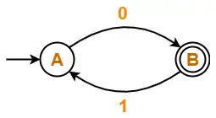
Ex. 7. Find regular expression for the following DFA using Arden’s Theorem-
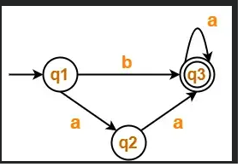
Ex.8. Find regular expression for the following DFA using Arden’s Theorem-
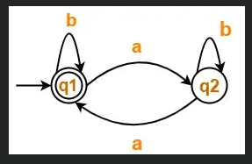
Ex. 9. Find regular expression for the following DFA using Arden’s Theorem-
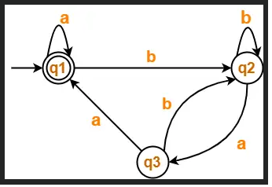
Ex. 10. L = {a^{i}b^{j} : i > j}
Prove that L is not regular by Pumping Lemma.
Ex. 11. L={ww : w in {a,b}*}
Prove that L is not regular by Pumping Lemma.
Ex. 12. L’ = {w₁w₂ : w₁,w₂ ϵ {a,b}*,|w₁|=|w₂|}
Prove that L is not regular by Pumping Lemma.
Ex. 13. Prove that L = {a^{i}b^{i} | i ≥ 0} is not regular.
Ex. 14. Design a PDA for accepting a language {a^{n}b^{2n} | n>=1}.
Ex. 15. Design a PDA for accepting a language {0^{n}1^{m}0^{n} | m, n>=1}.
Ex. 16. Lww^{r} = { ww^{r} : w∈{0,1}* }
Ex. 17. Design a PDA for 0^{n}1^{n}.
Ex. 18. Design a PDA for wcw^{r} {wcw | c is some special symbol not in w}
Ex. 19. Write the regular expression for the language
L={ab^{n} w:n>=3,w∈(a,b)⁺}.
Ex. 20. Write the regular expression for the language
L={w: |w| mod 3=0} ,w∈(a,b)*}.
Ex. 21. Find the regular expression for the following
a) L={a^{n}b^{m,}n>=1,m>=1,n,m>=3}
b) L={ab^{n}w :n>=3,w∈(a,b)⁺}
c) L={a^{n}: n>=0,n!=3}
Ex. 22. Write a regular expression for the set of strings of 0,s and 1,s not containing 101 as a sub string.
Ex. 23. Write the regular expression over alphabet (a,b,c) containing at least one a and at least one b.

